Ideation Phase
Define the Problem Statements

Date | 22 February 2026
Team ID | LTVIP2026TMIDS42582
Project Name | Home-Rentals
Maximum Marks | 2 Marks

Customer Problem Statement – Home-Rentals Platform
1. Target Customers
- Students and working professionals relocating to new cities
- Families looking for short-term or long-term rental homes
- Property owners who want to list and manage rentals easily

2. Customer Situation
People searching for rental homes often struggle to find reliable listings, compare options, and communicate with property owners efficiently. Many existing platforms provide outdated information, hidden costs, or complicated booking processes, making the rental experience stressful and time-consuming.
3. Customer Needs
Customers need a platform that:
- Provides verified and up-to-date property listings
- Offers clear pricing with no hidden charges
- Allows easy search, filtering, and comparison
- Enables secure communication between renters and owners
- Supports simple booking and documentation

4. Problem Statement
Renters and property owners need a reliable, transparent, and user-friendly rental platform because existing solutions are fragmented, unreliable, and time-consuming, making the process of finding and managing rental homes inefficient and stressful.
5. Why This Problem Matters
Solving this problem will:
- Reduce stress for renters relocating to new places
- Help property owners reach genuine tenants
- Save time through streamlined booking and communication
- Build trust through verified listings and transparent pricing

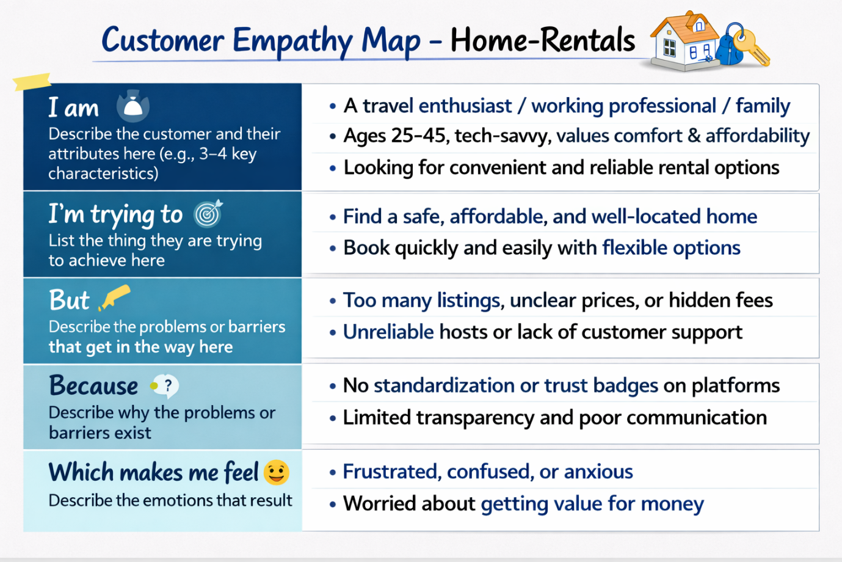

Reference: https://miro.com/templates/customer-problem-statement/
Example: 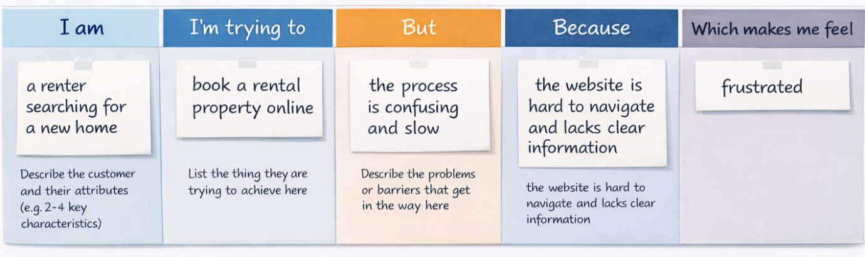
Problem Statement (PS) | I am (Customer) | I’m trying to | But | Because | Which makes me feel
PS-1 | a renter looking for a home | book a rental property online | the booking process is confusing | the website lacks clear instructions and info | frustrated and uncertain
PS-2 | a landlord listing a property | find reliable tenants quickly | not getting enough tenant inquiries | my listing isn’t visible or attractive enough | worried and disappointed

